Supplementary HPC Catalogue
for 2019

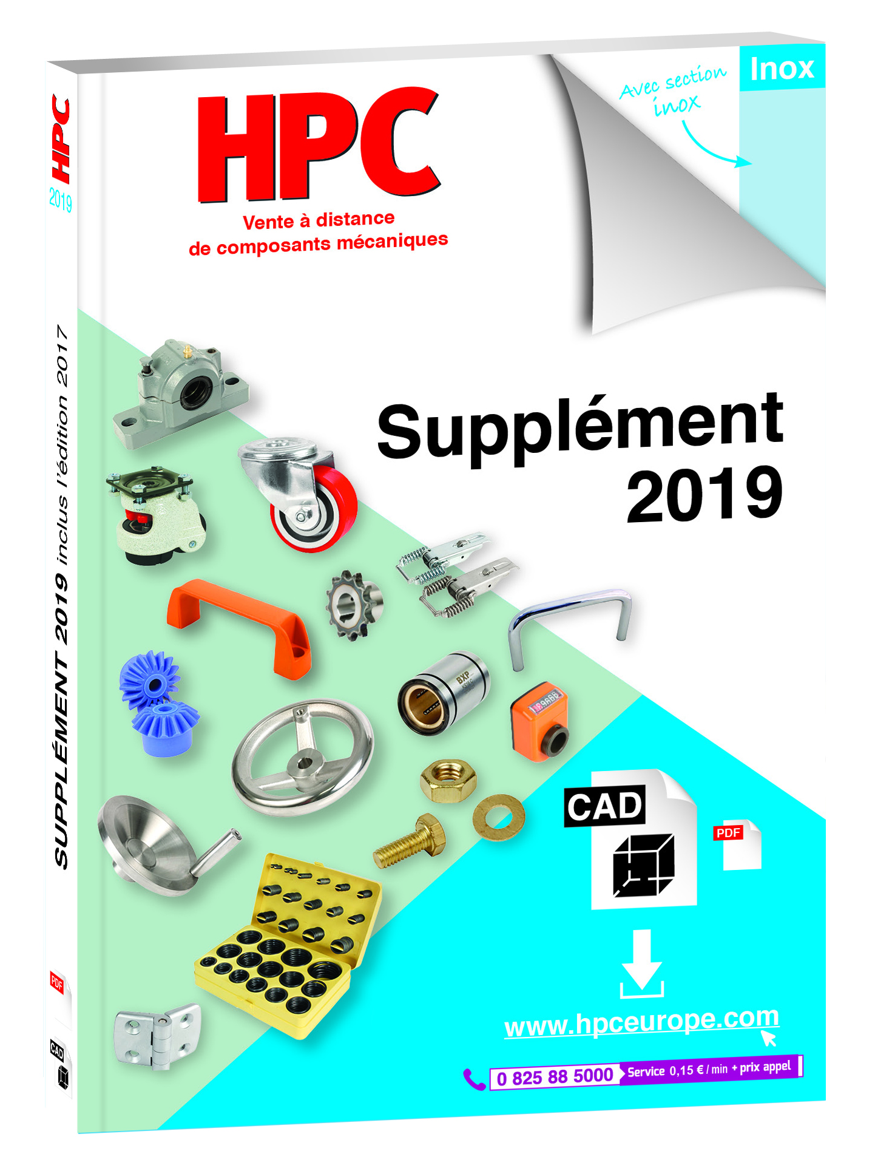
Engrenages HPC has published its latest catalogue: the 2019 Supplement. This edition completes the already widely known 5 volumes that were published in 2016. In this 300-page supplement you will find all of the new products that were introduced in 2017 and 2018 and those added in 2019.

The first part of the 2019 Supplement, identified by a blue border, gives details of a wide range of new stainless-steel products. These include innovative new product ranges for the food industry including:
- Moulded spur and bevel gears made from blue PA6 nylon suitable for contact with food.
- Hygienic Design® stainless steel components that meet the strict design rules for components and machine elements used in the food, pharmaceutical and chemical industries
- Patented Hygienic Usit® stainless steel components with special smooth designs that allow efficient sealing while still being easy to clean
- New Hypoid stainless-steel gearboxes that complement the existing range of gearboxes and motors for the food industry

The second part of the catalogue contains an expanded range of kits of components that will be especially useful in workshops and by materials handling and maintenance departments. These new kits include assortments of self-tapping inserts for wood, steel and stainless-steel clamps, nitrile O-rings (NBR 70 Sh or NBR 90 Sh), DIN985 self-locking nuts, DIN934 hexagonal nuts and DIN125 plain washers. HPC has also augmented its ranges of castors, chain wheels, sprockets, spur gears and load-bearing balls and has added other essentials that complete their existing ranges: steering wheels and handles, guide and fixing elements, casing accessories, screwing elements, feet, aluminium profile accessories, etc.

This new catalogue is available for download from the website www.hpceurope.com and can also be sent free of charge by post on request.

